|  |
| --- |
| Hiveboard.ca |
| HiveBoard |
| Version 1.0 |

|  |
| --- |
| 3-11-2023 |

Contents

Layout 2

Addressing 1

I2CAddressing 1

Pump Control 1

Screen 1

Wiring 1

PWM Inputs 1

I2C 1

Level Shifter 2

PWM Outputs 2

DroneBoard Connectors 2

Isolated EZO™ Connectors 2

Non-Isolated EZO™ Connectors 2

JST-SH I2C Connectors 2

Non-Isolated EZO™ Connectors 3

I2C Connector 3

Isolated EZO™ Circuit Connector 3

Setup 3

Powering the Board 3

PWM Control 3

I2C 4

Cooling 4

## Layout

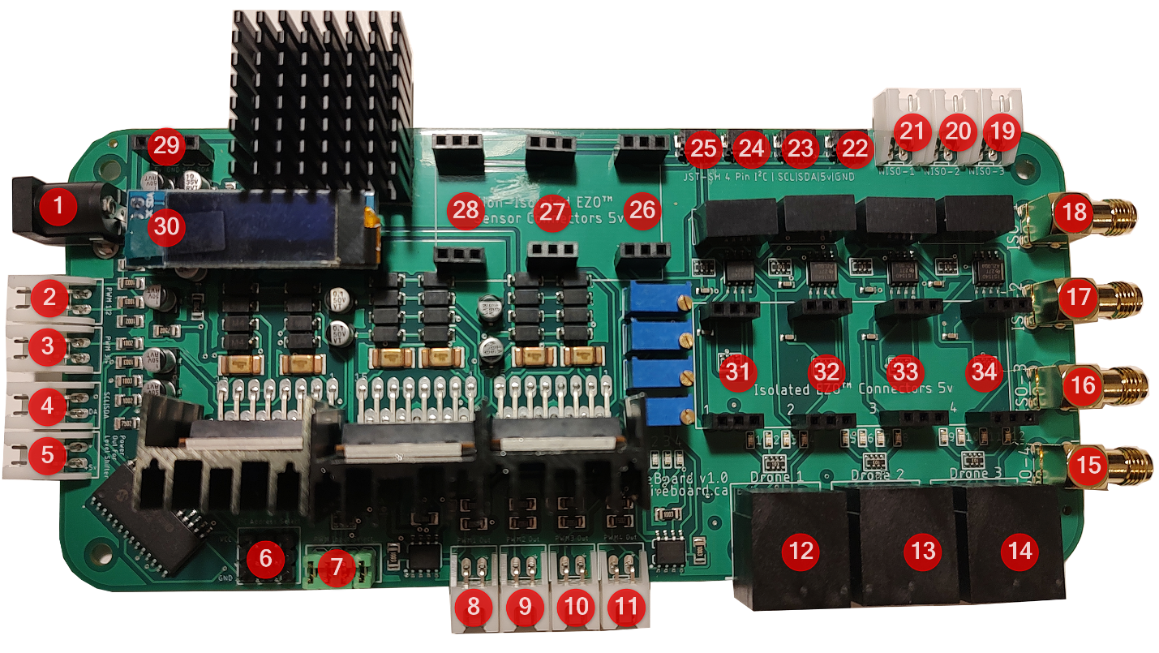

1. Power In

2-3. PWM Inputs

1. SDA/SCL Data In
2. Level Shifter Connection
3. Board I2C Select
4. PWM Input Select
   1. PWM Out

12-14. DroneBoards Outputs

15-18. Isolated EZO™ Sensor Connectors

19-21. Non-Isolated EZO™ Sensor Connectors

22-25. JST Connector

26-28. Non-Isolated EZO™ Circuit Connector

29. I2C Connection

30. Screen

31-34. Isolated EZO™ Circuit Connector

## Addressing

### I2CAddressing

The I2C address of the HiveBoard is controlled by the jumper pin. The Board I2C Select is labelled #6 on the Layout diagram. Possible address is (0x20-0x27)

|  |  |  |  |
| --- | --- | --- | --- |
|  | 20 |  | 25 |
|  | 21 |  | 26 |
|  | 22 |  | 27 |
|  | 24 |  |  |

### Pump Control

The pump is controlled by a MCP23017 chip with the addresses below:

|  |  |  |  |
| --- | --- | --- | --- |
| Channel 0 | Drone1 Output1 | Channel 8 | Drone3 Output1 |
| Channel 1 | Drone1 Output2 | Channel 9 | Drone3 Output2 |
| Channel 2 | Drone1 Output3 | Channel 10 | Drone3 Output3 |
| Channel 3 | Drone1 Output4 | Channel 11 | Drone3 Output4 |
| Channel 4 | Drone2 Output1 | Channel 12 | LED1/PWM1 |
| Channel 5 | Drone2 Output2 | Channel 13 | LED2/PWM2 |
| Channel 6 | Drone2 Output3 | Channel 14 | LED3/PWM3 |
| Channel 7 | Drone2 Output4 | Channel 15 | LED4/PWM4 |

### Screen

The screen’s address is 3c

## Wiring

### PWM Inputs

Labelled as #2 and #3 on the Layout diagram – please see PWM input section under Setup for more information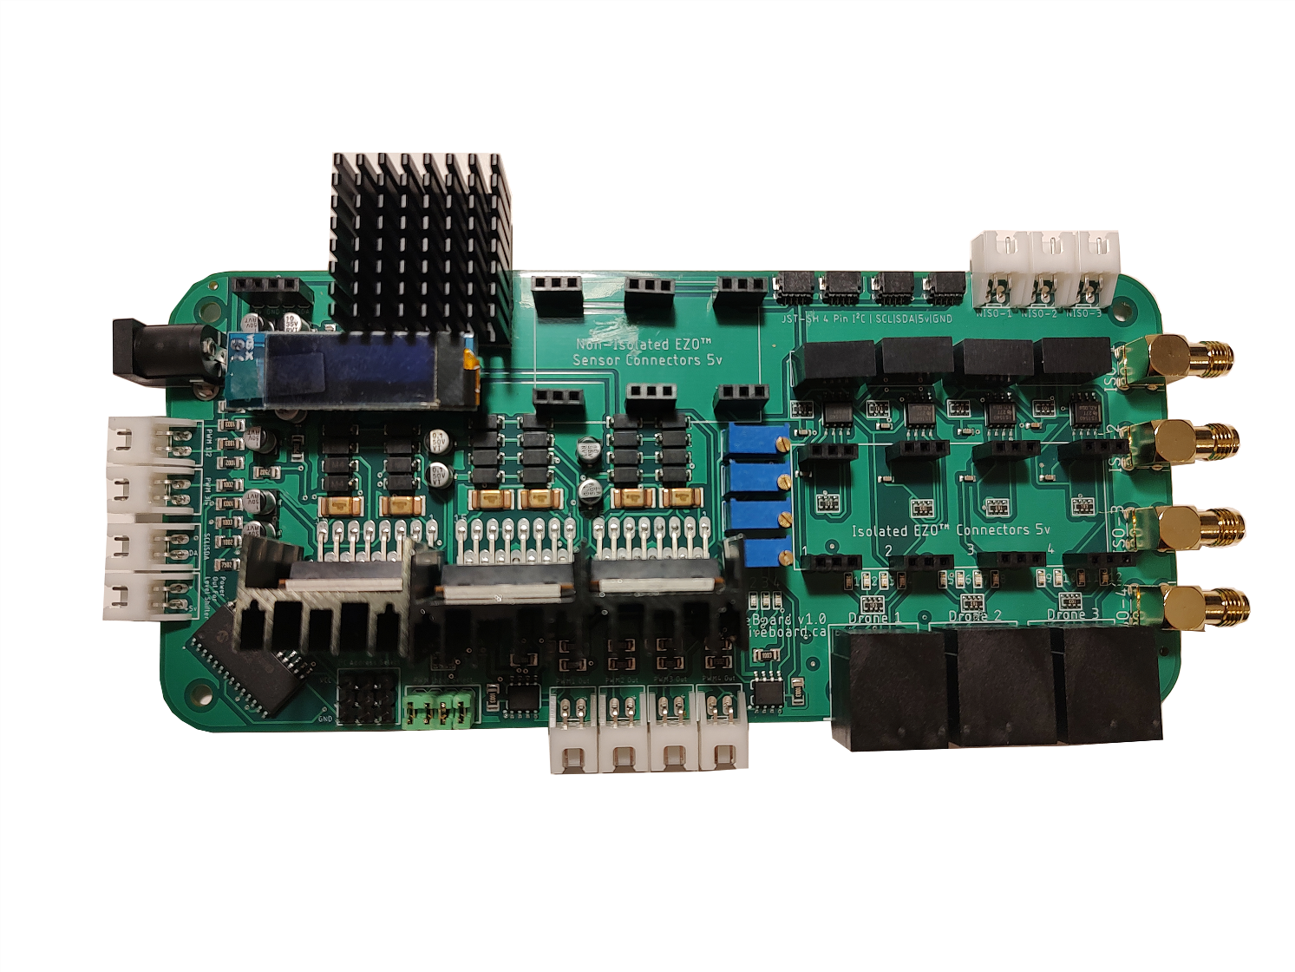

|  |  |
| --- | --- |
|  | If one is planning to control PWM externally through a SBC then they would connect the GPIO to these pins |

### I2C

Labelled as #4 on the Layout diagram

|  |  |
| --- | --- |
|  | The board I2C runs at 5V and not 3.3V. A level shifter is recommended |

### Level Shifter

Labelled as #5 on the Layout diagram

|  |  |
| --- | --- |
|  | When connecting the HiveBoard to a SBC where the I2C is not running at 5V, a level shifter should be used. One should use these pins to provide the reference high voltage and ground for the level shifter. Using a level shifter is recommended regardless to ensure compatibility |

### PWM Outputs

Labelled as #8-#11 on the Layout diagram – Please see PWM section for more information on PWM signal

|  |  |
| --- | --- |
|  | Each PWM output is wired (+/-) |

### DroneBoard Connectors

Labelled as #12-#14 on Layout diagram

The DroneBoards provide 4 outputs each as well as a I2C connection

One can use a standard ethernet cable to connect the HiveBoard to the DroneBoard and DroneBoard Basic. If one is making their own breakout board, the wiring of the Drone connectors is as below. All outputs run at ~9.5V. It is enough voltage for most 12v pumps

|  |  |
| --- | --- |
| 1. SCL | 5. 5V |
| 2. Output 4 | 6. Output2 |
| 3. SDA | 7. GND |
| 4. Output3 | 8. Output 1 |

### Isolated EZO™ Connectors

Labelled as #15-#18 on the Layout diagram

|  |  |
| --- | --- |
|  | Standard SMA Connectors |

### Non-Isolated EZO™ Connectors

Labelled as #19-#21 on the Layout diagram

|  |  |
| --- | --- |
|  | Standard JST-XH 2 pin Connector for sensor probe  Wired as GND/PRB+ |

### JST-SH I2C Connectors

Labelled as #22-#25 on the Layout diagram

|  |  |
| --- | --- |
|  | JST-SH 4 pin connectors  Wired for I2C as (SDA/SCL/5V/GND)  Compatible with STEMMA QT |

### Non-Isolated EZO™ Connectors

Labelled as #26-#28 on the Layout diagram

|  |  |
| --- | --- |
|  | Runs at 5v  Designed For:  Atlas Scientific EZO™ Temperature Probe  Atlas Scientific EZO™ Flow Totalizer |

### I2C Connector

Labelled as #29 on the Layout diagram

|  |  |
| --- | --- |
|  | Wired to Accept most Adafruit Sensors  Wired as 5v/GND/SCL/SDA |

### Isolated EZO™ Circuit Connector

Labelled as #31-#34 on the Layout diagram

|  |  |
| --- | --- |
|  | Runs at 5v  Designed For:  Atlas Scientific EZO™ pH Sensor  Atlas Scientific EZO™ ORP Sensor  Atlas Scientific EZO™ Electrical Conductivity Sensor  Atlas Scientific EZO™ Dissolved Oxygen Sensor  Atlas Scientific EZO™ Temperature Sensor  Atlas Scientific EZO™ Flow Totalizer |

## Setup

### Powering the Board

Labelled as #1 on the Layout diagram

The HiveBoard is designed to be powered by 12VDC. The board provides power for I2C communication

### PWM Control

The PWM outputs can be controlled both internally and externally via jumper pin (#7). Enabling the jumper pin enables internal control. If one wants to control them externally they would be connecting the GPIO from their SBC to the connectors and leaving the jumpers empty. If one wants to use the onboard PWM control they should not connect anything to the connectors.

****Currently Mycodo is not designed to handle the PWM being controlled internally by the MCP23017 chip, instead of PWM control the LED’s will be activated and the PWM outputs will run at 100% duty cycle****

When controlling externally the PWM control has 2 possible voltage (V) ranges.

The range is 0-5V by default; to operate at 0-10V one would also have the equivalent channel enabled from the MCP23017 (channels 12-15)

### I2C

This board provides its own power to the I2C communication. Do not connect any external power source to the I2C power source

Wired at 5v

### Cooling

This device has quite a few components that generate heat. It’s recommended that one does not keep the HiveBoard in a sealed place; some active cooling is necessary.

In testing it was found that at least a 40 mm fan with airflow over the heatsink (specifically above the screen) was sufficient.